Chapter 18, Solution 15.

(a) 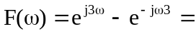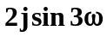

- Let 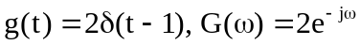
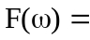 F 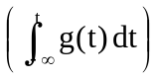
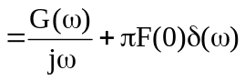
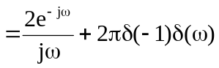
= 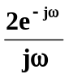

- F 